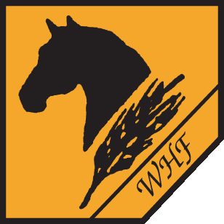

White Harvest Farms

Rates and Fees

Indoor Board (includes turnout) ……………………………………………………………………….. $675

Outside Sheltered Run ……………………………………………………………………………………… $500

Training Rides (per contact) ……………………………………………………………………………… $30

Lessons
Boarded Private Horse (private ) .………………………………………………………… $60
Boarded Private Horse (group) ……………………………………………………………. $30
School Horse (private) ..……………………………………………………………………….. $75
School Horse (group) …………………………………………………………………………… $45
Practice Ride (by appt. only) ……………………………………………………………….. $20
Lesson with Cattle ……………………………………………………………………………….. $ above + $20

Services
Full Body Clip (w/o sedation) ………………………………………………………………. $150
Full Body Clip (w/sedation) …………………………………………………………………. $185

Horse Show Fees:
Hauling ………………………………………………………………………………………………. pending dist./mileage
Day Training Fee ………………………………………………………………………………… $30
Horse Use Fee ……………………………………………………………………………………. $50/breed show
…………………………………………………………………………………….. $75/CHJA or USEF
Horse Show Care:
Full Care …………………………………………………………………………………. $75/day
Stall/Feed Care ………………………………………………………………………. $15/day
Feed Only ………………………………………………………………………………. $10/day
Bathing …………………………………………………………………………………… $25
Show Clipping …………………………………………………………………………. $35 Head/Face
…………………………………………………………………………. $50/Legs
Mane Pull…………………………………………………………………………………. $15
Braid…………………………………………………………………………………………. $50

